|  |  |
| --- | --- |
| **NAME :** | ARSATH H |
| **DEPARTMENT :** | INDUSTRIAL BIOTECHNOLOGY |
| **COLLEGE :** | GOVERNMENT COLLEGE OF TECHNOLOGY, COIMBATORE |
| **NAAN MUDHALVAN COURSE:** | DIGITAL MARKETING |
| **NAAN MUDHALVAN ID :** | C0A3B9AD0A9937292804059AB95DE749 |

ASSIGNMENT ON DIGITAL MARKETING

1. Create a blog or website using blogspot and wordpress.Customize the theme design and post new article with 500 words.

Blogspot:

<https://feastonwheelss.blogspot.com/>

Wordpress:

<https://feastonwheels.wordpress.com/2023/10/25/feast-on-wheels/>

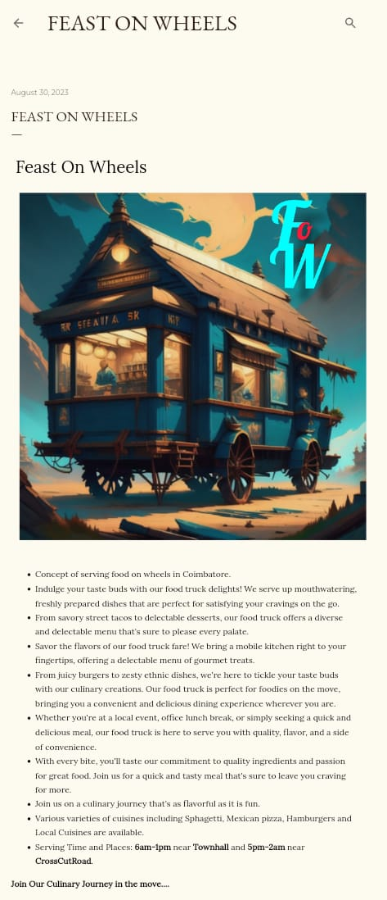

1. Create a new facebook business page and post one social media poster for your brand. <https://www.facebook.com/profile.php?id=61550920945382&mibextid=ZbWKwL>

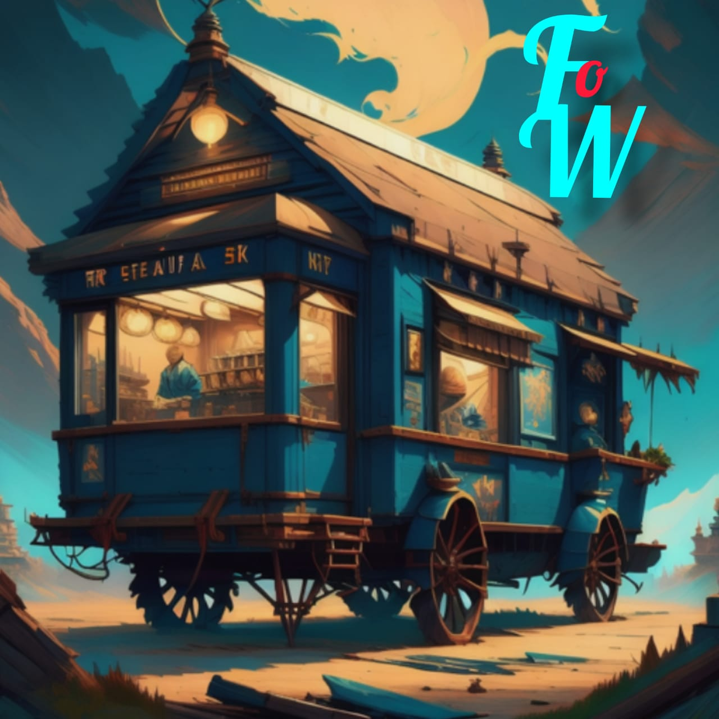

1. Create and design a social media advertisement poster using canva.

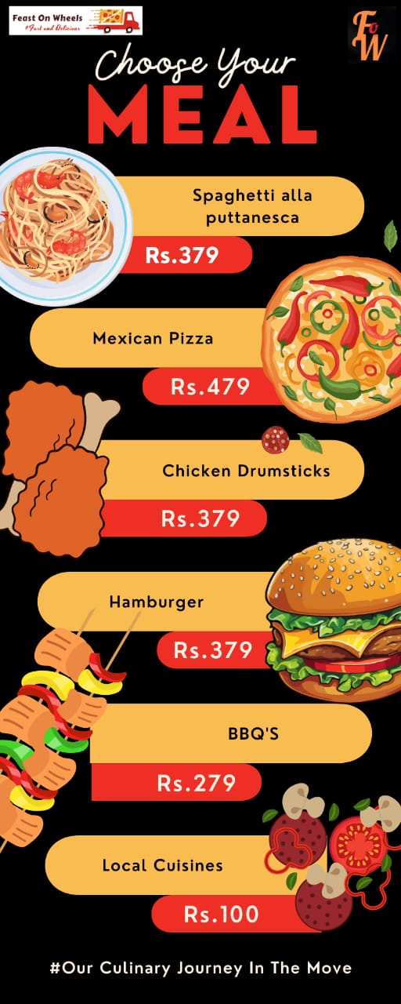

1. Create email newsletter design using Mailchimp or canva tool.